Quantifying production of hot firebrands using a fire-resistant fabric

Adusumilli et al.

Objective: characterizing the charring behavior of fire-resistant fabric.

Illustrate the fabric usage for firebrand generation studies.

Conclusion: Char mark area is an exponential function of the temperature, power input and time of exposure.

Ration of (hot firebrands/total firebrands) = 0.3 to 0.05

|  |  |
| --- | --- |
|  |  |

Findings

* At higher temperature charring is irrespective with contact time.
* At lower temperature charring was observed only the contact time is sufficient.

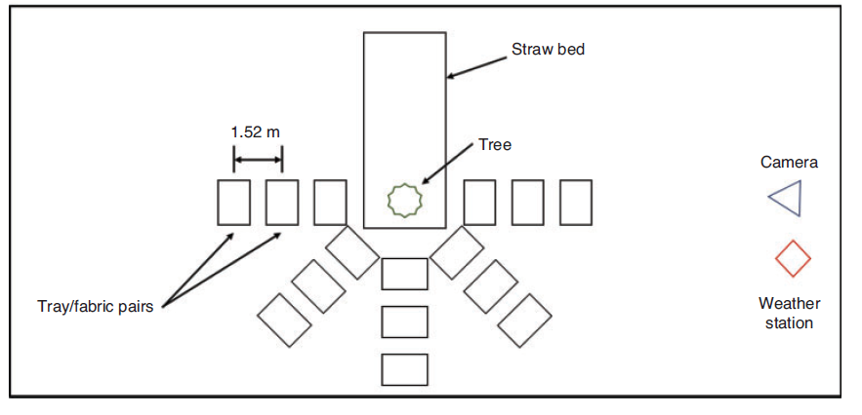

Findings

* Both tree types of trees (UT and FR) burnt similarly
* Both types of trees produced firebrands.
* The number of char marks lower by factor 5 for FR treated trees compared to untreated.
* The larger firebrands produced by FR treated trees, but the larger char marks from UT trees.

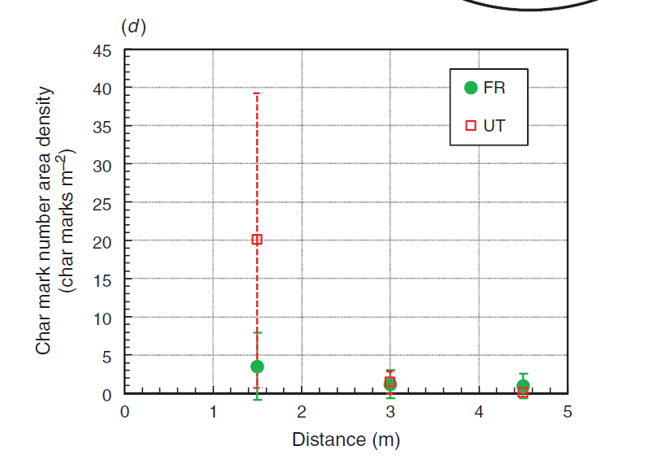

Simulation (Douglas fir tree) with Haider and Levenspiel + SECOND ORDER PARTICLE DISTRIBUTION

|  |  |
| --- | --- |
| Distance (m) | number density ( m-2) |
| 0.55 | 44.195 |
| 1 | 8.913 |
| 1.45 | 0.606 |

Experimental results and estimation

|  |  |  |  |  |
| --- | --- | --- | --- | --- |
| Distance (m) | char mark number density ( m-2) | | Estimation to the simulation | |
| UT | FR | UT | FR |
| 1.5 | 20.056 | 3.510 | 40.752 (0.55 m) | 6.394 (0.55 m) |
| 3 | 1.504 | 1.003 | 30.083 (1.00 m) | 4.903 (1.00 m) |
| 4.5 | 0.251 | 1.003 | 20.971 (1.45 m) | 3.636 (1.45 m) |

**second order polynomial used.

Multi-scale study of ember production and transport under multiple environment and fuel conditions

|  |
| --- |
|  |
|  |

Objectives:

1. Determine the physical parameters which have largest effect of ember generation.
2. Understand the changes of ember generation with natural and process wood burning.
3. Understand the effect of tree morphology on ember generation.
4. Find the fraction of embers which could start a spot fire.
5. Identify similarities/differences in the governing parameters between different scale studies.

Experimental procedure,

* 36 experiments done. 108 trees were burnt.
* Ambient wind speed = 0.59 m/s
* Tests were conducted with 1, 3, 5 trees to vary the heat release.

Douglas fir

|  |  |  |
| --- | --- | --- |
|  | Manzello et al (Douglas fir tree) | Hudson et al (Douglas fir tree) |
| Height (m) | 2.6 | 2.95 -4.67 |
| Moisture (%) | 10 | 13 - 59 |
| Initial mass (kg) | 10 | 2.53-9.83 |
| Mass loss (kg) | 4 | 0.53 – 3.93 |
| Wind (m/s) | 0 | 0.59 (ambient), fan (1.2, 1.0, 0.8) |



**2.4 m**

**1.1 m**

**1.2 m/s**

**1.0 m/s**

**0.8 m/s**

**Fire resistant fabrics**

**fan**

*not to the scale

Findings:

|  |  |
| --- | --- |
| Size of embers |  |
| Number flux |  |
| Propensity to ignite spot fires. |  |

Modelling:

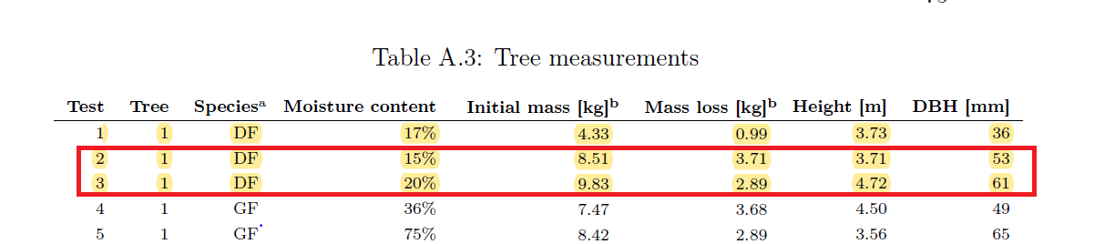

Hot firebrands

* Landing T=302 0C. (Hudson et al)
* Initial temperature = 311, 361, 411 0C (Wadhwani et al)